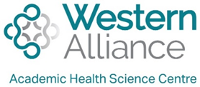
STaRR: Supporting Translation of Research in Rural and Regional Settings rting Trnslation

Expression of interest: ‘emerging researcher’ training program
Western Alliance’s STaRR program aims to build research and research translation capacity in rural and regional health settings. STaRR is a multidimensional research translation capacity building program.
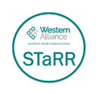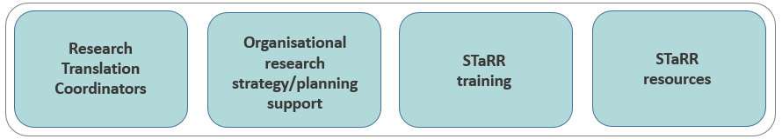

The aim of this two-workshop program is to provide health practitioners with the foundational research skills needed to develop a research translation-focused project (i.e., a project that will lead to changes in practice or policy). Participants will receive mentoring support and access to just-in-time resources to assist them with developing their project. Participants will also have an opportunity to apply for a limited number of emerging researcher grants (valued at up to $5k per grant) upon the completion of this program.

Who can participate?
All health practitioners, including clinicians, program managers, health promotion and PHN staff working within health service or primary care settings at a Western Alliance partner organisation. We encourage those with limited or no prior research experience to apply.

Workshops overview
The training will comprise of two 6.5-hour workshops that will be facilitated online. The workshops will be underpinned by the principles of research translation and will cover the following broad topics:
- General introduction to research | - Introduction to research methods
- Developing a researchable question | - Introduction to common data collection techniques
- Literature searching | - Introduction to data analysis
- Ethics and governance | - Research dissemination and impact
- Introduction to a research translation framework

How to complete your EOI
1. Identify a translation-focused research idea (i.e., a project that will lead to changes in practice or policy)
For support developing your research idea and completing your EOI, please contact your Western Alliance Research Translation Coordinator:
- Ballarat/East Grampians: Jaclyn Bishop Jaclyn.Bishop@eghs.net.au
- Geelong/Colac: Michael Field MField@cah.vic.gov.au
- Hamilton/Warrnambool: Louise Greenstock Louise.Greenstock@wdhs.net
2. Complete the EOI which requires your manager’s support and signature

3. Nominate your team members (we recommend a minimum of two people to support the project).
4. Submit completed EOI by 5pm on Tuesday 1st June 2021 to info@westernalliance.org.au

For more information contact Drew Aras drewaras@westernalliance.org.au
Timeline
EOIs | Open 3rd May and close 1st June (5pm)
Notification | 15th June
Workshops | (1) Mid-July and (2) Late August

STaRR: Supporting Translation of

Research in Rural and Regional Settings

Expression of interest: emerging researcher training
Please complete the following questions (maximum 200 words per response). We recommend contacting your local research translation coordinator to discuss your EOI and to support you as needed.

Participant selection will be based on the following questions, however selection will also consider geographic and organisational diversity.

- Please describe the health problem or issue you have identified at your organisation.

Enter text

- What evidence is there to support your identified health problem or issue at your organisation? (i.e., can you describe some local data that suggests there is a problem or issue?)

Enter text

- What change or benefit/s do you anticipate you will achieve by undertaking a research project on this health problem or issue?

Enter text

- Who will be on your research / research translation team? Please state your team members’ names, role in their organisation and the role they will play in the project (note that these team members may be practitioners, consumers, other researchers etc.)

Enter text

Your name: Enter text
Employing organisation: Enter text
Current role: Enter text
Email address: Enter text
Phone number: Enter text
Signature……………………………………………………….. . Date………………………………………………

Manager’s name: …………………………………………………… Manager’s signature: ………………………………………..

Submit completed EOI to info@westernalliance.org.au by 5pm Tuesday 1st June

EOI Checklist (please ensure the below points have been addressed prior to submitting your EOI):
- Have you addressed a healthcare practice or policy problem or gap for your organisation? ☐
- Does your idea have potential to lead to change in healthcare practice and/or policy? ☐
- Have you identified a research team? ☐
- Would participating in this program help to develop or enhance your research or research translation skills? ☐
- Do you have the support of your manager/s to participate in this program? ☐

